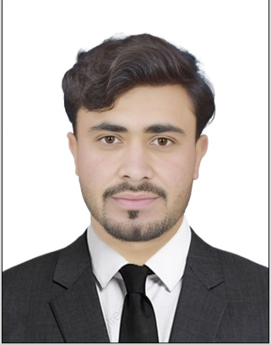
Curriculum vitae
MUHAMMAD IRFAN

Mobile: 0554728781
Email: urfankhan1006k@gmailccom

Post Applied for: for any job
Objective:
Seeking a suitable position in a reputable organization where creativity is accepted besides maximizing my potentials by exploiting present skills and continually developing new ones.
Personal Details:

Name
Name of Father Nationality Date of Birth
: Muhammad irfan
: Hakim Badshah
: Pakistan
: 07/07/2006

Marital Status : Single
Visa status : Student visa
Passport Details:
Number : MQ1980821
Place of Issue : ORAKZAI PAK
Date of Issue : 21/11/2024
Date of expiry : 20/11/2029
Educational Qualifications:
- Secondary school certificate
Languages Known:
- English
- Arabic
- Hindi
- pushto
Professional Experience:

- CURRENTLY WORKING AS A TYPIST AT SURAT AL INJAZ TYPING AL DHAID SHARJAH
- 02 YEARS OF EXPERIENCE AS A FILLING CLERK IN PAKISTAN
Skills:
- Good in Customer relation
- Excellent customer service and strong interpersonal skills.
- Sincere and hardworking
- Flexible
- Able to work under pressure
Declaration:

I hereby declare that the information furnished above are correct up to the best of my knowledge and I bear the responsibility for the correctness of the same.

Muhammad irfan

